Domestic Violence & Sexual Assault Training  Presented by the National Institute of Crime Prevention  Aug 27th and 28th, 2018  Training Topics  Model Policy for Law Enforcement Response to Domestic Violence • Preventing the Sexual Assault of Children • FETI-Forensic Experiential Trauma Interviewing • The Effects of Childhood Trauma in Later Years • Identifying Signs of Strangulation • Making Sure that Orders for DV Protection Work • The Psychology of Abuse, “Why Does He Do It?” • Developing Coordinated Community Programs to Combat Domestic Violence • Bystander Intervention in DV “How You Can Help”  Who Should Attend  Law Enforcement Officers, Licensed Clinical Social Workers, Victim Advocates, Prosecutors, Native American Leaders, Social Workers, Mental Health Workers, Educators, Substance Abuse Counselors, Rape Treatment Center Workers, Nurses, Batterers’ Intervention Counselors, Military Police, SHARPs, and SARCs.  Training Location  Oregon Trail Center  320 N. 4th St. Montpelier, ID 83254 | Free Training  ────  Register Below  ────  Agenda  ────  Hotel Info for :  Super 8  Clover Creek  Links Below  ────  CEU’s and POST Credits available  Hosted by: Montpelier Police Department Victim Assistance Unit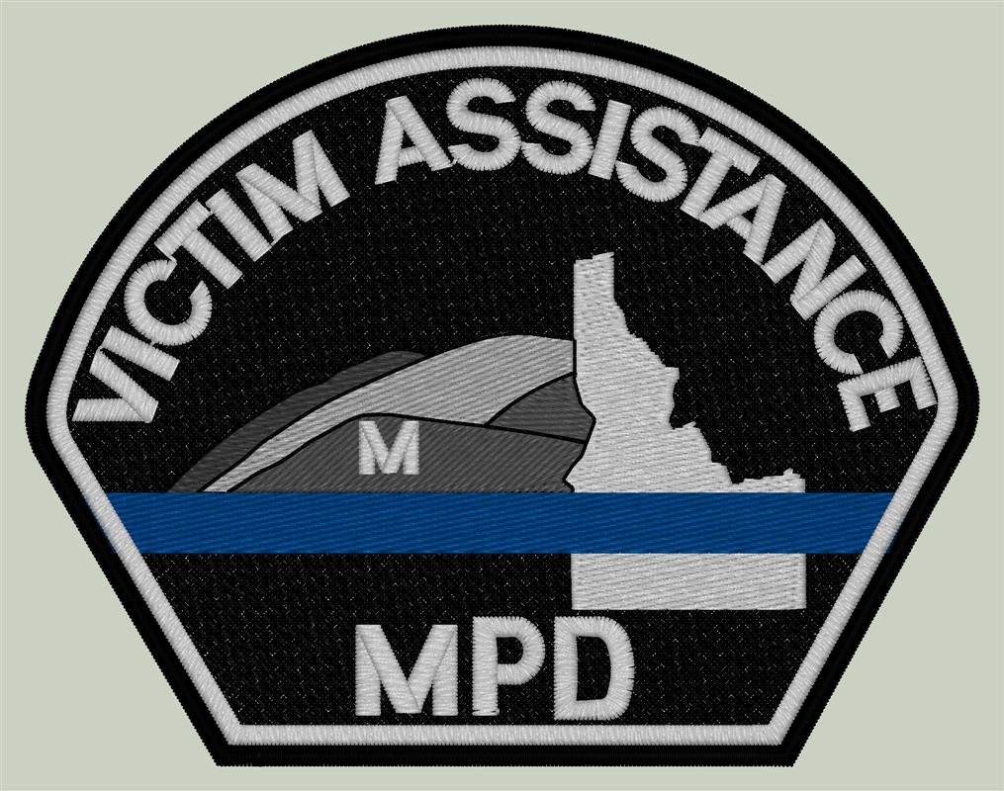  208-847-1324 ext. 111  shannonj@montpelierpd.com

